

EPG123 Installation and User's Guide

©2018 by GaRyan2  
<http://epg123.garyan2.net>

Version 1.2.9

29 December 2018

Table of Contents

Introduction 1

Acknowledgements 1

Installation 2

Requirements 2

Warnings 2

Software 2

Step 1 – Clean Start 3

Step 2 – TV Setup 4

Step 3 – Setup and Execute EPG123 5

Transfer Recording Requests from Backup 9

Manual Importing and Matching 11

Final Step – Create a Scheduled Task 12

Custom Configurations/Tools 13

Additional OTA Configuration 13

Include Station Logos 13

Download Station Logos 13

Rebuild Database 14

Backup Current WMC Configuration 14

Restore Previous WMC Configuration 14

Command Line Arguments 14

Tweak WMC Guide and Features 15

# Introduction

For many Windows Media Center TV users, July 2015 was not a good month. Microsoft changed their provider of guide data from the highly stable and reliable Zap2it (**Tribune**), to the almost amateurish Rovi (**Rovi Corp**). To be fair to Rovi, the data provided by them to Microsoft is probably fine, but the execution of the transfer and the continuing struggles has been amazingly disappointing.

EPG123 was created to not only compensate for the lacking guide information, but to also relieve the user from relying on Microsoft and/or Rovi to fill their guide with accurate information. The guide information downloaded by EPG123 is provided by Gracenote (**Tribune**) via servers maintained by Schedules Direct. EPG123 delivers that highly stable and reliable data that is expected to even include some customization. Most importantly, though, it provides the user with some control over their own destiny for TV watching and recording.

# Acknowledgements

This project was born out of frustration and desperation following the transfer from Zap2it to Rovi. It could never have made it as far as it has without the involvement of a lot of WMC enthusiasts and users at The Green Button (<http://www.thegreenbutton.tv>). Many of the improvements and features were born of their experiences and suggestions. There was also quite a bit of technical support provided by Schedules Direct to ensure the EPG123 client/server interaction was optimal.

This product has met the approved application requirements of being free and/or use an OSI-approved Open Source license that does not violate the Schedules Direct Terms of Use or Subscriber Agreement. <http://schedulesdirect.org>

This product uses the TMDb API but is not endorsed or certified by TMDb.

<http://www.themoviedb.org>



This product uses TheTVDB API. All series, season, episode, and actor images and overview text are the property of the submitter and are available to non-commercial projects under the CC 3.0 Non-Commercial Attribution license. <http://www.thetvdb.com>

This product uses the Newtonsoft Json.NET library and is granted permission, free of charge, per the MIT License. <http://www.newtonsoft.com/json>

# Installation

## Requirements

* Membership to Schedules Direct (<http://schedulesdirect.org>)
* Windows 7/8/8.1 version of Windows Media Center
* .NET Framework 3.5 and 4.0 minimum
* 1GB hard drive space (typically much less)
* Internet connection
* 15 - 30 minutes to perform a basic installation

## Warnings

Though EPG123 has demonstrated the capability to coexist with Microsoft/Rovi guide data, it is nonetheless recommended to begin with a clean start by performing Step 1. The existence of the Rovi data has the potential to override the guide data (low risk) as well as cause channels to completely disappear (medium risk). The data also introduces some strange behavior in the Movie Guide and category searches.

Performing this procedure will come at some cost.

* All guide customization will be lost (callsigns, channel numbers, favorite lineups, logos, ...)
* Some or All of the scheduled recording requests may be lost. Users in the US with Rovi guide data will be able to recover most, if not all, of their previous recording requests.

## Software

Download the latest version of EPG123 from <http://epg123.garyan2.net> and execute the setup file. The setup will install the appropriate software, shortcuts, uninstall file, and configure any registry entries necessary to successfully use EPG123 to provide guide data to your Windows Media Centers.

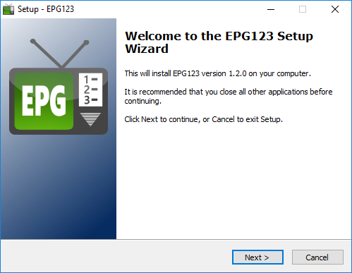

**NOTE**

If performing an upgrade from a previous version of EPG123, it is only necessary to run the setup file. No further action is required.

**NOTE**

If you are only installing the Server side of EPG123 to create the MXF and/or XMLTV files, skip to **Step 3 – Setup and Execute EPG123** on page 5.

## Step 1 – Clean Start

This step creates a backup of the current WMC tuner configurations, guide subscriptions, and scheduled recordings in the **[epg123]\backup** folder. The contents of the C:\ProgramData\Microsoft\eHome folder is deleted to remove all traces of the previous EPG database. If a Hauppauge Colossus HD PVR software tuner is installed, the software tuner configuration files located in C:\ProgramData\Hauppauge\MediaCenterService are deleted as well.

1. Start the **EPG123 Client** program.
2. In the ***Client Configuration & Actions*** group, click the **[Client Setup]** button.

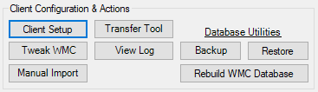

1. Click the **[Step 1: Clean Start]** button and wait for it to complete.

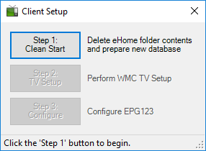

**NOTE**

This step can take some amount of time depending on the speed of the HTPC as well as how active the hard drive is at the time. When the backup has completed, and the new database has been prepared, the **[Step 1: Clean Start]** button will turn green and the **[Step 2: TV Setup]** button will be available to continue with the next step.

## Step 2 – TV Setup

To prevent MS/Rovi from corrupting the guide, it is necessary to deny the Program Guide Terms of Service.

1. Click the **[Step 2: TV Setup]** button.
2. Select **[live tv setup]** on the **TV** menu strip.
3. 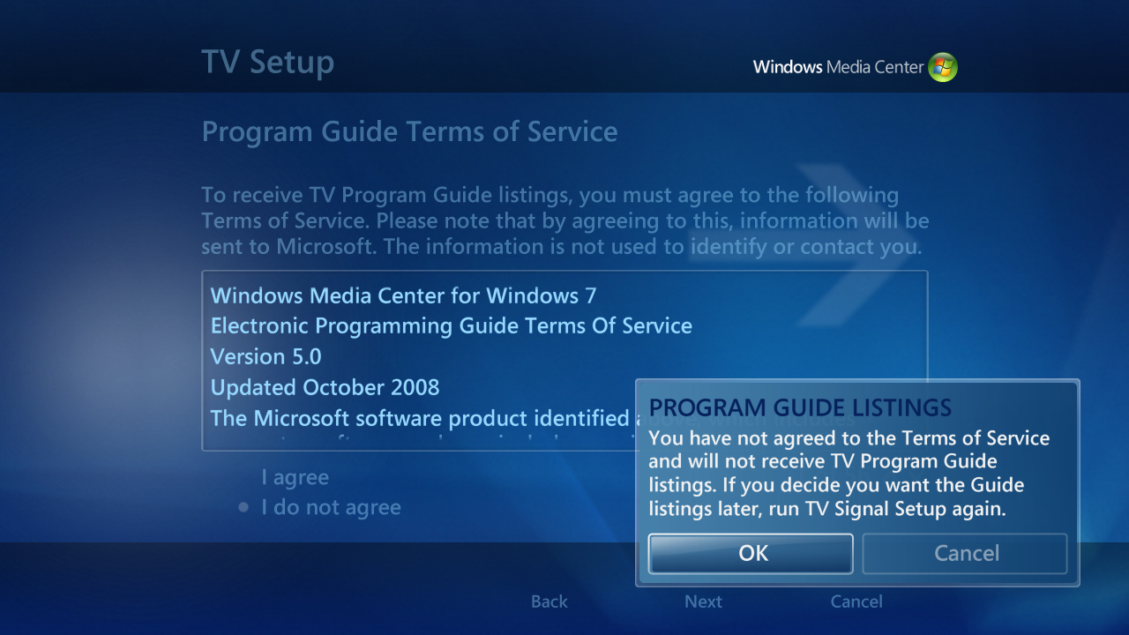Proceed with TV setup as normal until the **'Program Guide Terms of Service'** screen. Select the ‘**I do not agree’** radio button and click **[Next]**.
4. Click the **[OK]** button on the warning prompt and proceed with the setup until complete.

**NOTE**

For CableCARD™ users, the activation and pairing of the card with the tuner remains valid even after performing Step 1. For all the setup pages related to activating the CableCARD™, just select the **(Yes)** bubbles and click the **[Next]** buttons to proceed. It will not be necessary to contact your cable provider to re-activate the card.

1. For those with Over-the-Air (OTA) tuners, some additional setup may be required. Refer to **Additional OTA Configuration** on page 13.
2. Close Windows Media Center.

## Step 3 – Setup and Execute EPG123

**A Schedules Direct account needs to be established prior to this step**. There is no configuration to perform on their website which only manages the XML server; EPG123 uses the JSON server.

1. Click the **[Step 3: Configure]** button to open the **EPG123 Configuration** program.
2. Enter the **Login Name** and **Password** of the Schedules Direct account to be used and click the **[Login]** button.

#### Subscribe Lineups to Account

1. If there are no lineups associated with the account, the **'Subscribed Lineups'** window will be presented automatically. If there are already lineups associated with the account and changes are desired, click the **[Lineups]** button below the **[Login]** button. Otherwise, proceed to step 9.

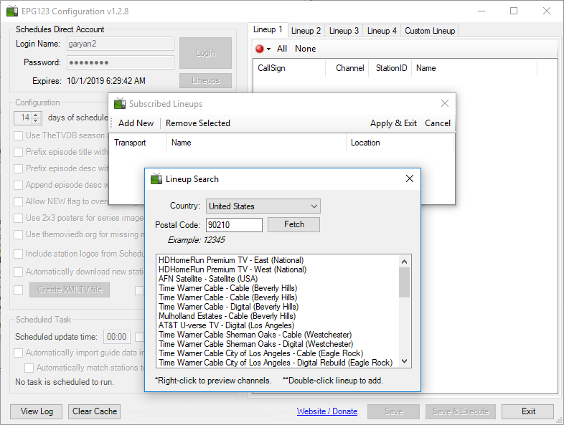

1. Click the **[Add New]** control button to bring up the **'Lineup Search'** window.
2. Select the **Country** and enter the **Postal Code** of the lineups to search for and click the **[Fetch]** button.
3. Double-Click the desired lineup to add from the fetch results.
4. Repeat steps 4 - 6 as necessary to subscribe to as many as 4 lineups.

**WARNING**

Schedules Direct limits the number of lineup additions to a maximum of 6 in any 24-hour period. Ensure the desired lineups are subscribed to within that limitation.

1. Click the **[Apply & Exit]** button on the **'Subscribed Lineups'** window.

#### Select Stations to Download

1. For each subscribed lineup in the tabbed panel, select the desired stations to download guide information for by checking the box next to the station call sign.

**NOTE**

Stations that are common within and between lineups are linked. This means that if a station is selected for download in one lineup, it will also be selected in the other lineup(s). The same is true when a station is de-selected.

**ANOTHER NOTE**

Be aware of stations assigned to the same channel number. Sometimes a provider will list both SD and HD stations on the same channel. For the most accurate guide, only select the station that is appropriate to your specific source.

1. Ensure each lineup is included in the guide download. The selection will be identified by both the green bubble on the toolstrip and the checkmark by the **‘Include’** menu item.

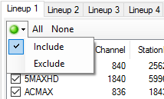

#### Select Customization Options

1. In the **Configuration** panel, set the parameters according to the desired usage and outcome.

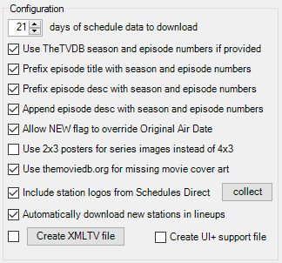

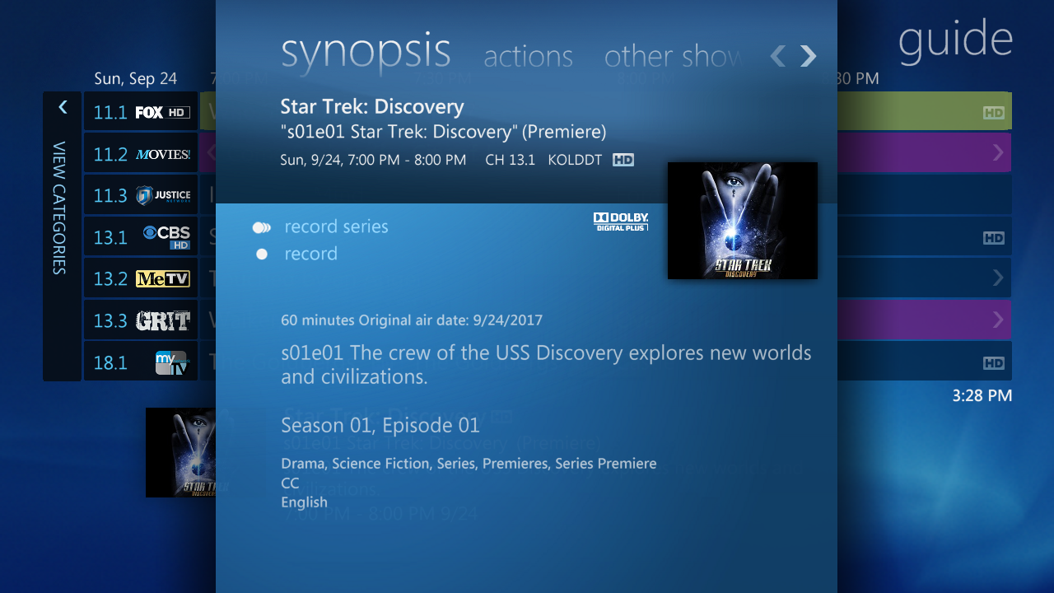

🗹 *Prefix episode title with season and episode numbers;* 🗹 *Prefix episode description with season and episode numbers;*

🗹 *Append episode description with season and episode numbers;* 🗹 *Allow NEW flag to override Original Air Date;*

🗹 *Include station logos from Schedules Direct;* 🗹*Use 2x3 posters for series images instead of 4x3 (4x3 shown)*



🗹 *Use themoviedb.org for missing movie cover art*

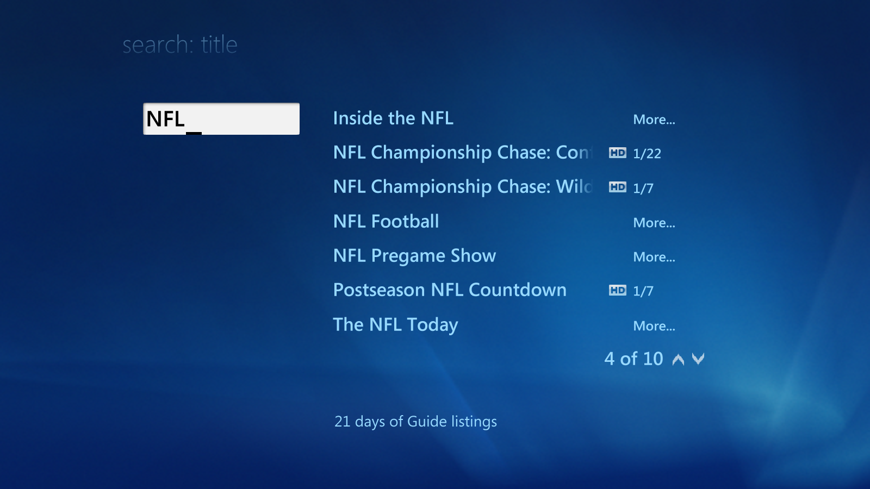

🗹 *Number of days of schedule data to download*

1. Refer to **Include Station Logos** on page 13 and **Download Station Logos** on page 13 for more detail of these options.
2. The **‘Automatically download new stations in lineups’** checkbox, when selected, will download any **new** stations to the subscribed lineups if it is also new to the included lineups.

#### Configure Completion Activities

1. Selecting the **‘Automatically import guide data into WMC’** checkbox will direct EPG123 to import the updated guide into the Windows Media Center database of the host machine. This setting will be overridden by the scheduled task if different.
2. Selecting the **‘Automatically match stations to channels’** checkbox will direct EPG123 to attach the listings of a station to the guide channel by matching the channel numbers. This setting will be overridden by the scheduled task if different.

**NOTE**

The automatic match routine uses the original channel numbers of the scanned tuners to determine a match. Custom numbers have no effect on the logic. If the subscribed lineup channel numbers are not correct for your provider/region, DO NOT select this option.

#### Execute

1. Click the **[Save & Execute]** button to save the configuration and immediately start downloading guide data to perform the update as configured.

## Transfer Recording Requests from Backup

A method has been developed to lessen the burden of a transition from Rovi to EPG123 by providing a tool to translate Rovi recording requests into EPG123 recording requests and importing them into the WMC database. The translation table is continually being updated and relies heavily on the ability of Rovi to provide accurate guide information used to compare with guide information from Gracenote.

1. Open the **EPG123 Transfer Tool**. The right panel will be populated with any recording requests currently in the WMC database.
   1. Requests that are green are compatible with an EPG123 WMC database.
   2. Any request can be cancelled by right-clicking the item and selecting Cancel.
2. Click the **[Open recordings backup file]** button to import a recordings backup file. The file can be a standalone MXF file or as part of the compressed ZIP file created by the **Backup Current WMC Configuration** procedure.
3. The contents of the backup file are analyzed and presented in the left panel.
   1. Requests that are green are transferrable into the EPG123 WMC database. These items are selected for transfer automatically.
   2. Requests that are pink are Rovi requests that have not yet been translated to a Gracenote value. These items are not selectable and cannot be transferred to the WMC database.
4. Click the **[ > > > ]** button to transfer the old recording requests to the WMC database.

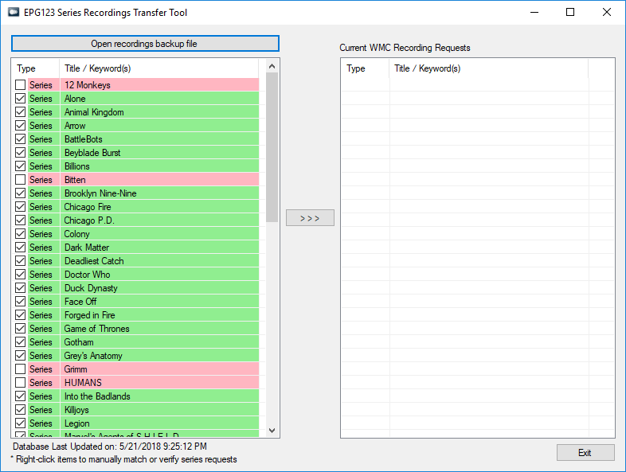

For those series that have not yet been added to the translation table, a more manual method has been developed using the services provided by TheTVDB (<http://thetvdb.com>).

1. Right click the series to open a new window with the MS/Rovi series information and TheTVDB title search results.

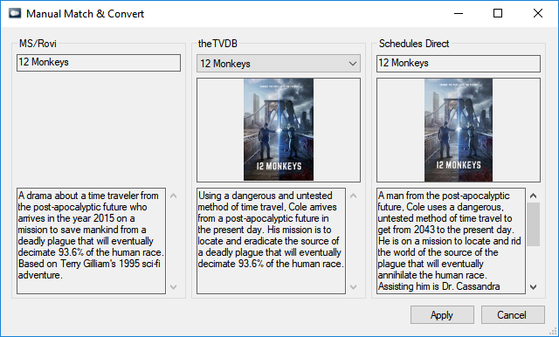

1. Select the matching title in the TheTVDB title combo box and if it contains the ID for Gracenote, that will be presented in the Schedules Direct panel.
2. Verify the Schedules Direct series displayed corresponds with the MS/Rovi that is being transferred over and click the **[Apply]** button.

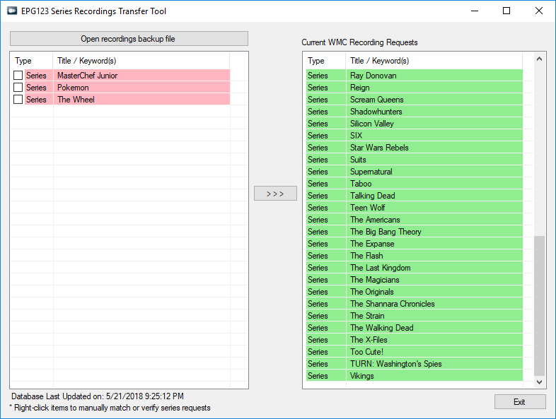

## Manual Importing and Matching

If either ‘Automatically import’ or ‘Automatically match’ options were not selected, some manual operations need to be performed to populate the guide using the **EPG123 Client** program.

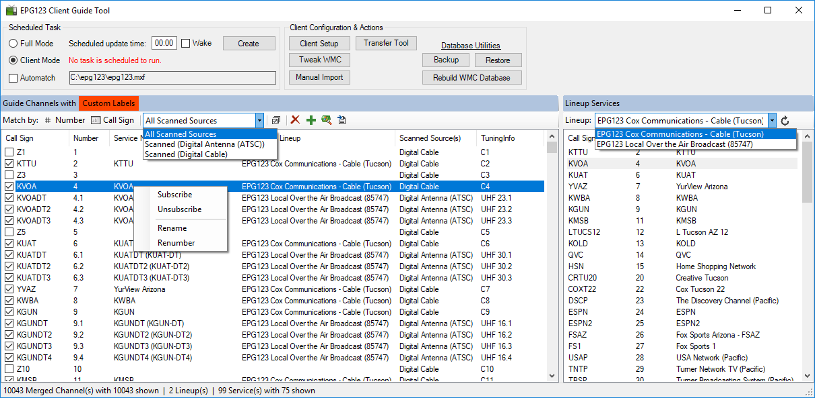

#### Manual Import

The **[Manual Import]** button is used to import any MXF file into the WMC database. Once the file import has completed, the guide channels (Left) and the lineup services (Right) will be refreshed to include any new data.

#### Matching Lineup Service to Guide Channels

For the most part, manually matching the guide channels with the lineup services is intuitive. The below list provides some of the GUI rules in performing this operation.

* The guide channels can be filtered by Scanned Sources
* The lineup services can be filtered by Lineup
* Match by **[Number]** and **[Call Sign]** buttons are available to quickly scan the viewed lineup on the right and all viewable channels on the left
* The checkbox reflects the Enable/Disable state of the channel in the guide
* Multiple channels on the left can be selected for subscribing, unsubscribing, and deleting guide channels
* Only 1 channel on the right can be selected at a time for subscribing to a guide channel
* To subscribe a channel, at least 1 must be selected on the left and 1 selected on the right
* The labels toggle button is used to toggle between the original call signs and channel numbers with the custom call signs and channel numbers for matching.

## Final Step – Create a Scheduled Task

To keep the guide listings continually updated, it is necessary to create a daily task to execute epg123 and/or epg123Client. The intended role of the machine will determine which method to use.

#### Server Mode

The server mode is limiting EPG123 to just creating the MXF file for import by another machine. The task needs to be scheduled using the **EPG123 Configuration** GUI with the ‘Automatically import’ option unchecked. The location of the MXF file must be accessible to any clients.

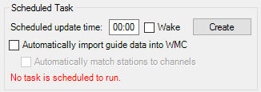

#### Client Mode

The client mode is used by machines that do not generate the MXF file but imports the file from another location (i.e. a different machine in Server Mode or Full Mode). The task needs to be scheduled using the **EPG123 Client** GUI and the path to the MXF file set in the text box.

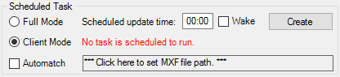

**NOTE**

If the location of the remote MXF file is user/password protected, it will be necessary to edit the task in Task Scheduler to provide the appropriate credentials.

#### Full Mode

The full mode operation is used to create and import the MXF file on the same machine. The task can be scheduled using either the **EPG123 Configuration** GUI with the ‘Automatically import’ option checked, or using the **EPG123 Client** GUI with the ‘Full Mode’ radio button selected.

#### Create the Task

1. Enter the time daily updates are desired to be executed in 24-hour time format.
2. Check the **Wake** checkbox if the scheduled task is to wake the computer to perform the task at the scheduled time. If this is not checked then the task will run as soon as it can after the station has been turned back on.
3. Click the **[Create]** button to create the task.

# Custom Configurations/Tools

## Additional OTA Configuration

Some OTA users will have missing channels once the setup scanning has completed. This is due to Windows Media Center not scanning the VHF frequencies during setup which are the physical channels 2 - 13. For those missing channels, it will be necessary to manually add them in WMC.

To determine what the missing station physical (also known as real) channel is, along with the digital (also known as logical) channel is, it will be necessary to either look that information up or use another source such as the tuner itself and its software package. A useful source for US OTA information is <http://www.tvfool.com>.

1. Select **[settings]→[TV]→[Guide]→[Add Missing Channels]** from the **Tasks** menu strip.
2. For each missing digital TV channel:
   1. Select **[Add DTV Channel]**.
   2. Enter the digital/logical channel to add and click the **[Next]** button.
   3. Enter the assigned frequency (physical/real channel) and click the **[Next]** button.
   4. Enter the call sign of the station and click the **[Add]** button.
3. For each missing analog TV channel:
   1. Select **[Add Channel]**.
   2. Enter the assigned frequency and click the **[Next]** button.
   3. Enter the call sign of the station and click the **[Add]** button.

## Include Station Logos

The ability to include station logos is a built-in feature of WMC that was never used by Microsoft, Zap2it, or Rovi. EPG123 provides the ability to incorporate custom logos provided by the user or Schedules Direct and stored in the **[epg123]\logos** folder. **A benefit of including station logos is they are embedded in the MXF file. Any client that imports the MXF file will also get the station logos.**

Logo must be:

* A portable network graphic (PNG) file
* Name must match the station call sign (i.e. ESPNHD.png)
* Recommended aspect ratio is 3:1; logos downloaded from Schedules Direct will be a maximum 360x120 while “big” logos from My Channel Logos XL (<http://www.mychannellogos.com>) are a maximum 225x75.
* Placed in the **[epg123]\logos** folder

## Download Station Logos

In support of including station logos in the generated MXF file, a button is provided on the **EPG123 Configuration** GUI labeled **[collect]**. Clicking the button will download all station logos from the subscribed lineups and saves them to the **[epg123]\sdlogos** folder, cropped and named by the respective call sign. The logos are high quality, but are not optimized for the Windows Media Center in size, aspect ratio, or color scheme. The downloaded logos are an excellent starting point to edit for the guide using a tool like Paint.NET (<http://www.getpaint.net>) or GIMP (<https://www.gimp.org>). The completed logo images can then be copied into **[epg123]\logos** folder for inclusion in the guide on the next update.

## Rebuild Database

There are times that Windows Media Center will refuse to update some programming in the Guide even though EPG123 is importing correct information. This usually occurs when there have been programming changes due to current events or special circumstances. If an error is noticed, and possibly verified on the Zap2It website (<http://tvschedule.zap2it.com/>), the EPG123 Client GUI provides a method to rebuild the WMC database with the latest guide data.

**NOTE**

Prior to deleting and rebuilding the database, EPG123 will force a WMC mini-update to create a snapshot of the current tuner configurations and scheduled recordings. This process can take some time but is typically short.

1. Using the **EPG123 Client** GUI, click the **[Rebuild WMC Database]** button.
2. Upon successful deletion of the database, a search form will appear to select the MXF file to import.

## Backup Current WMC Configuration

It is possible to take a snapshot of your current WMC configurations (tuner configurations, subscribed lineups, custom channel names and numbers, and scheduled recording requests) for restoral later if desired. Open the **EPG123 Client** GUI and click the **[Backup]** button. The compressed zip file with the configurations will be saved in the **[epg123]\backup** folder as *backups_yyyyMMdd_HHmmss.zip*.

## Restore Previous WMC Configuration

Restoring a previous WMC configuration is very similar to the **Rebuild Database** feature except it uses the archived ZIP file from the **Backup Current WMC Configuration**. These files can be used to quickly restore WMC to its previous state but without any guide listings. The tuners will be restored with whatever custom call signs, numbers, and listings were present at that time.

1. Open the **EPG123 Client** GUI and click the **[Restore]** button.
2. For native lineups, the guide listings will have to be downloaded and for EPG123 lineups, the guide listings will have to be imported for a full restore.

## Command Line Arguments

#### EPG123.EXE [-UPDATE] [-P]

-UPDATE Creates the WMC EPG guide MXF file according to the configuration settings.  
-P Displays a message box with progress bars while building the guide MXF file.

#### EPG123CLIENT.EXE [-I source [-F]] [-MATCH] [-NOLOGO] [-P] [-X]

-I source Imports the specified MXF file into the WMC EPG database.  
-F Forces import regardless of WMC tuner recording status.  
-MATCH Performs the automatching of epg123 stations to the tuner channels in the WMC EPG database.  
-NOLOGO Removes all channel logos from the guide.  
-P Displays a message box with a progress bar during import.  
-X Enable advanced buttons to browse and export the WMC store (database)

## Tweak WMC Guide and Features

As part of the **EPG123 Client** program, it is possible to tweak some WMC settings related to the guide, recordings, and playback. Click the **[Tweak WMC]** button to access the form.

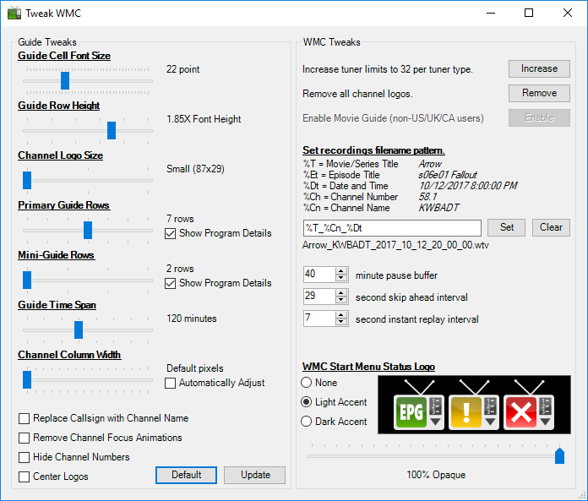

Examples:

